SYSTEM DESIGN AND ARCHITECTURE:
PROJECT
WEEK:2

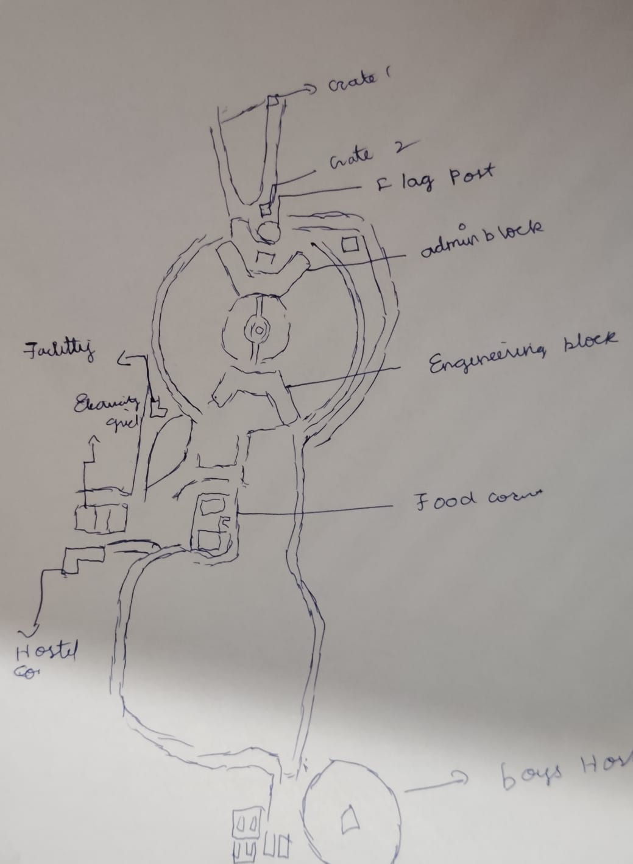
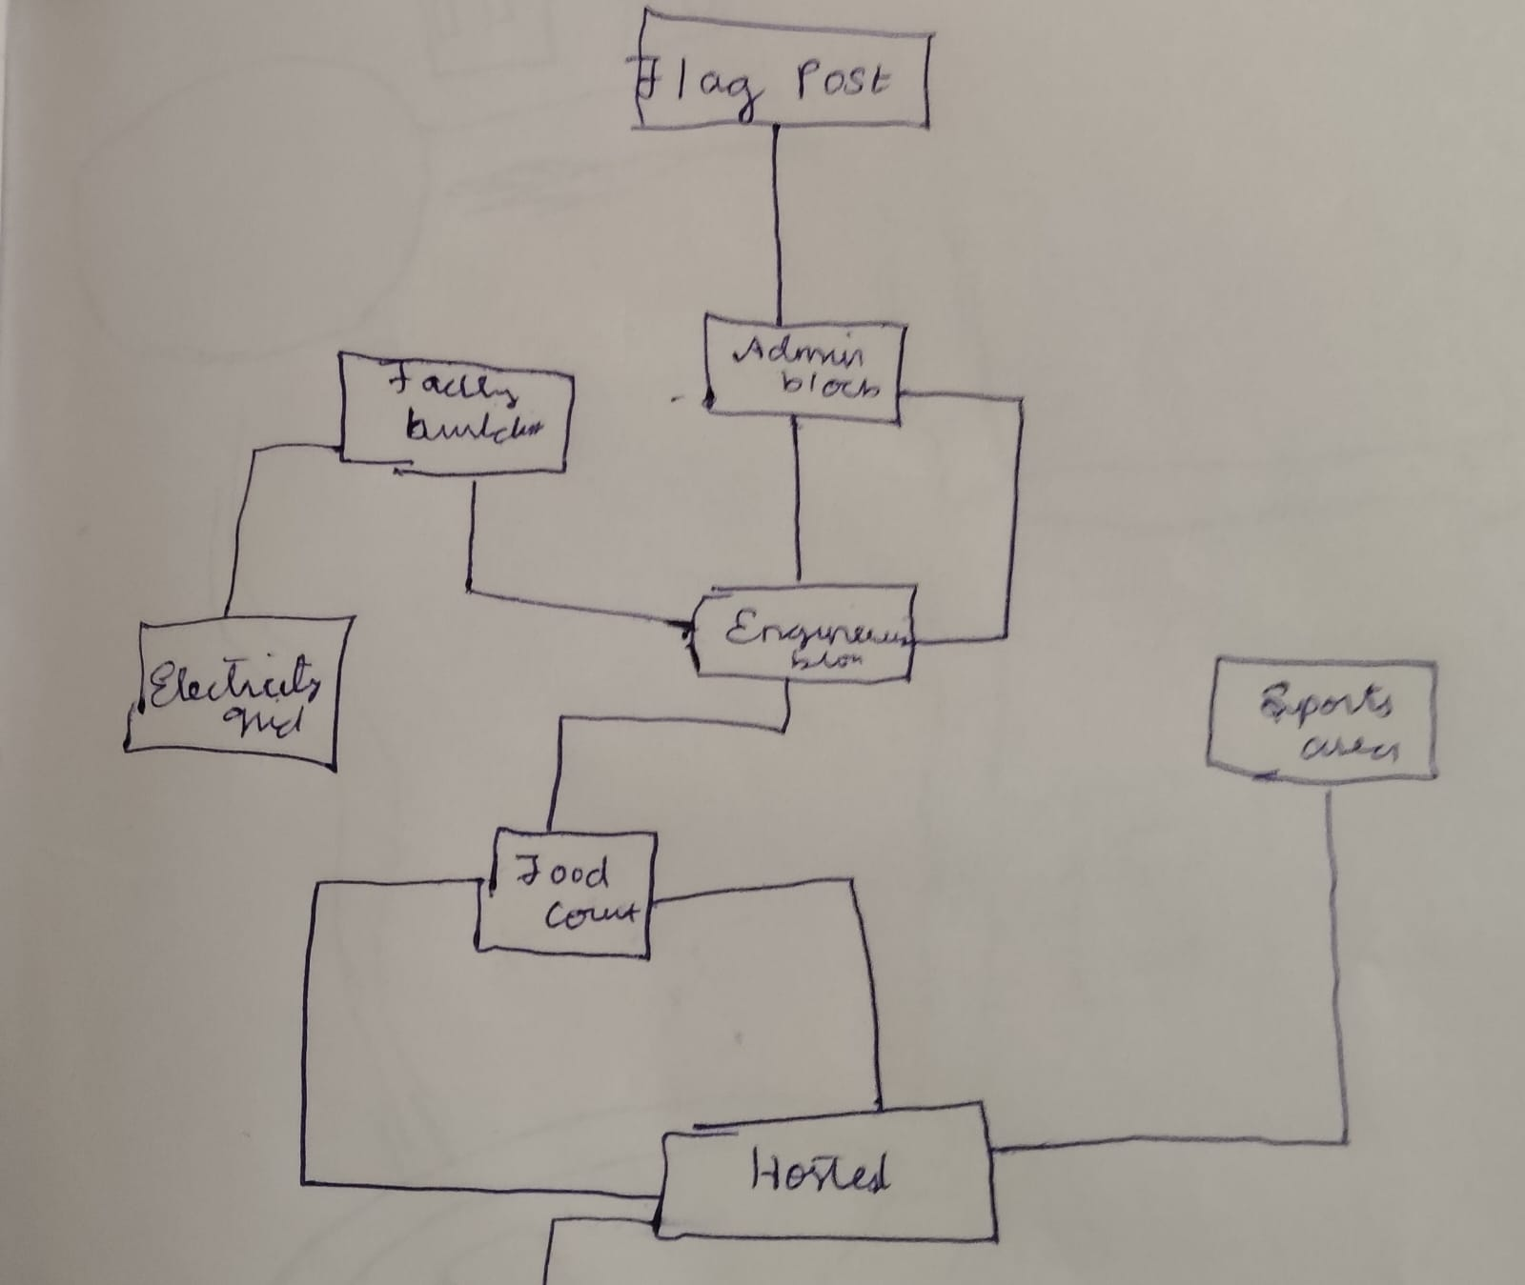

Gate 1 → Gate 2 ⇒ 180 m
Gate 2 → Admin block ⇒ 75 m
Gate 2 → Parents hostel ⇒ 283 m
Admin → Eng block ⇒ 125 m
Admin → Parents hostel ⇒ 250 m
Eng block → Food court ⇒ 215 m
Eng block → Staff hostel ⇒ 170 m
Food court → Staff hostel ⇒ 215 m
Eng block → Parents hostel ⇒ 305 m
Food court → Hostel-1 ⇒ 271 m
Hostel-1 → Eng block ⇒ 438 m
Hostel-1 → (Sport area / Ground) ⇒ 565 m
Parents hostel → Food court ⇒ 415 m
Parents hostel → Hostel-1 ⇒ 645 m

